Rogers Canyon High School Ungulate and Human Conflict Unit Curriculum Pilot Project
Final Report
Compiled by Charles Vogelheim, Masters Candidate
May 11, 2015

Contents
Introduction 3
Initial Lesson Plan 3
Rationale 4
Learning Objectives: 4
Next Generation Science Standards Addressed: 4
Times: 4
Assessments: 5
The Unit 5
Week 1: Land Management, Ungulates, and Rogers Canyon 5
Week 2: The Nature of Science & Developing a Research Project 8
Week 3: Conducting Scientific Research and Applications 10
Actual Class 11
Evaluation 13
Post-test 13
Survey Results 14
Statistical analysis 14
Free response results 15
Allometry Equation 17
Potential Papers for Students to Use 18
Final Project Examples 18
Successes 21
Challenges 21
Support 23
Standards 23
Next Generation Science Standards 23
Wyoming State Standards 25
Expanding this unit further 26
Contacts: 27
Summary 27

Introduction
The Biodiversity institute created this position for two reasons. Firstly several researchers at the university needed to fulfill an outreach component that many research grants require (NSF especially). Secondly, several educators had approached the BI asking for some kind of curriculum based on research being done at the university. Therefore the BI funded a part-time GA to develop a curriculum that could be passed out to Wyoming High School Biology/Ecology teachers that would be based on some type of research being done here.
In initial conversations, it was determined that this project would have the following goals:
- Based off a professor’s research at UW
- Have elements of the nature of science: students asking questions and testing them
- Have students go out into the field and collect data based on their questions in ways similar to the research
- Have multimedia elements (videos of professors/grad students talking about research and/or demonstrating research techniques)
- Take about three weeks in length
- Align to Next Generation Science Standards
In shopping for a professor to help out with this, several issues came to light:
- Most researchers do their fieldwork in the summer – not during the school year
- Most researchers collect data in specific locations, it would be hard to create a state-wide lesson plan that any Wyoming teacher could use
- Most researchers are extremely busy and do not have much time to collaborate to develop something like this
After some conversations with local high school teachers about their needs with such a project, the decision was made to develop a pilot project with teacher, Dustin Giesenhagen. He teaches an Ecology Elective at Laramie Senior High School where they go out to Rogers Canyon, north of town, to talk about deer and ungulate winter habitat and human pressures on that. It was decided that the project would focus on Rogers Canyon and connect to the bigger issues of ungulate migration, with which there is much research being done at the university. As ungulates are present in all parts of the state and these animals are very important culturally to the state, we determined that a curriculum could be developed that could apply to all parts of the state.
This class was an excellent pilot class for this project as it is an elective class, the teacher was no required to teach to standards and there was flexibility to experiment with new units. This class consisted mostly of upperclassmen and women and due to the nature of it being an elective, it had students who were excited about science and students who had struggled with science and were taking this elective in order to graduate. Therefore it had both highly motivated students and ones not very excited to be there.

Initial Lesson Plan
This lesson plan was developed for the Rogers Canyon Unit. Since Rogers Canyon is on BLM land and much of the discussion around ungulate migration has to do with federal management of lands, a major part of the lesson focused on discussing federal agencies and land management. Also, because of the interest of the GA, NGSS requirements, and educational research showing increased interest in science if the learning had authentic elements, there was an element of service-learning added where students would try to develop a solution to a problem, presumably that they found with their scientific study.
The following is the initial lesson plan:

Rationale
For many high school students, the subject of science is seen as something distant, unapproachable, uninteresting, and impractical. This leads to a negative view on science, a disinterest in the subject, and potentially even a distrust of scientists themselves. This project aims to develop a unit that can be used in high school biology classes throughout the state of Wyoming that engages students in science, connects them with their local community, and has them interact with university science researchers through the scientific process. The first unit will be a project-based unit centering on the subject of ungulate management. Between hunting and tourism, all residents of the state have a relationship with these animals. Recent research is showing that ungulates travel much further than previously thought and their intersecting migration paths throughout the state offer a strong ecological connection throughout the state. The pilot project will take place with a Laramie High School Ecology course focused on a piece of BLM land called Rogers Canyon. Locals heavily use this land as a place to practice shooting, and as such, there is a large human impact on the land. Mule deer and elk use the land as a wintering ground. Not much is known how much human impacts are affecting their habitat there. With the guidance of UW researchers, students will assess the area to see how critical the habitat is for ungulates, assess whether BLM should change its current management of the land, and develop a project to improve the land for ungulate use.

Learning Objectives:
- Science processes and public demand inform land management decisions
- Science is problem-based
- Minor human actions impact ungulate behavior
- University researchers provide insight to how ecology is understood
- Living things require a specific set of needs in order to live​

Next Generation Science Standards Performance Expectations Addressed:
- HS-LS2-2 Use mathematical representations to support and revise explanations based on evidence about factors affecting biodiversity and populations in ecosystems of different scales
- HS-LS2-6 Evaluate the claims, evidence, and reasoning that the complex interactions in ecosystems maintain relatively consistent numbers and types of organisms in stable conditions, but changing conditions may result in a new ecosystem
- HS-LS2-7 Design, evaluate, and refine a solution for reducing the impacts of human activities on the environment and biodiversity

Times:
- Monday, Thursday, Friday 12:26-1:16, 2:20-3:10
- Tuesday 11:55-1:25, 1:30-3:05
- Start on March 23rd

Assessments:
- Class participation
- Research proposal
- Final Presentation (poster)
- Journal reflections
- Pre/post tests

The Unit

Week 1: Land Management, Ungulates, and Rogers Canyon

Monday March 24: How are decisions made about how public land is managed?
Overview:
  - Introduction to BLM & USFS
  - University’s relationship with state & public lands
  - Introduction to Rogers Canyon
Plan:
- Pass out a pre-test asking students about both knowledge and emotions toward scientific research and public lands.
- Ask “what are public lands?”
  - Separate students into groups and have them research different public land organizations: NFS, NPS, FWS, BLM (maybe also Game and Fish, Wyoming State Parks, etc.)
  - Have students fill out a chart identifying each organization’s mission and/or motto, overseeing agency, land type they manage, how it is managed (preservation? conservation? recreation?), who benefits from the management
  - Have students present their findings, and fill in the rest of their chart
  - Engage in a discussion on the similarities and the differences between the organizations. Discuss how despite the lands being public, how are locals impacted and how can they influence what is going on in their backyard?
- Discuss the history of land-grant universities and have a brief conversation them and their relationship to public lands
  - Questions:
    - What is a university?
    - What kinds of research is being done there?
    - How might it be helpful for public lands?
- Introduce Rogers Canyon (this could be done the following day), give a brief presentation on how it is currently used, and what is going on there:
  - BLM land - has a grazing lease for sheep, hasn’t really been used
  - Locals use it for birdwatching, climbing, hiking, biking, etc.
  - Last 10 years has seen new trails for ORVs, more shooting, litter
  - BLM is stretched thin, office is in Rawlins and person in charge of monitoring has over 100 other sites to monitor
  - Locals report fewer wildlife
- What is your opinion on public lands? Do you think they are an important asset to our country? Why or why not?

Tuesday March 24: How do land managers monitor the land?
Plan
- Before telling them anything about the site, students spend 10 minutes walking around site, to get a first impression
- Have students reflect in their journal on their first impressions, encourage them to draw, micro/macro pictures of the place, make a list of adjectives describing it, write a poem. Have them answer: What do you notice, if any, the big problems for the habitat are here?
  - Come together and share
- Introduce BLM’s way of monitoring sites for vegetation, the transect
  - Why use vegetation to monitor for habitat quality?
  - What other factors do animals need for habitat?
  - Why is this a permanent transect, why is it useful to test the same place every year?
  - What information can we gather from this?
- Give a lesson on plant ID, have students draw different plants in their notebooks to help
- Break students into groups, have them complete survey

Thursday March 26: How do scientists assess the status of an ecosystem?
Plan
- Review what a habitat is and why they are important to study
  - Through a silent conversation, have students define what a habitat and an ecosystem is (draw “HABITAT” and “ECOSYSTEM” on the board with a circle, invite students to silently come up and add bubbles to it to include elements that define them and make them)
  - Decide upon the best definition of a habitat from this exercise (generally the environmental conditions an organism needs to live and survive, including climate, physical structure, space, food/forage, moisture/water) and of an ecosystem (interactions of living and nonliving aspects of the environment)
  - Facilitate discussion on why it is important to study habitats of organisms and the ecosystems they live in. (bring in migration initiative - GIS data types maps)
    - How do habitats of different organisms compare to one another?
    - What do habitat needs tell us about organisms?
    - What practical use would a knowledge about habitats be for a land manager?
    - How might someone come to know the habitat requirements of an organism?
    - How is the concept of habitat related to the concept of an ecosystem? How are they similar and how are they different?
    - How do you define ecosystem boundaries?

Friday March 28: How do human activities affect ecosystems?
- Brainstorm with students various ways that human activities impact ecosystems and habitats that may cause the organisms in them to leave and/or change, base on observations of field observations
  - Human disturbance (look at migration initiative figures)
    - Roads
    - Construction
    - Trails
    - Trash
    - Shooting
  - Invasive species (cheatgrass & fire regime)
  - Poor land management (grazing)
  - Climate change
  - How might these affect the organisms in a particular ecosystem?
- Introduce the concept of alternative stable states and ecosystem thresholds
  - Ecosystems can exist in a number of stable states that they can switch over to when perturbed. Often it doesn’t take much energy to go into an alternative stable state but it takes much more energy to switch back to the original stable state (ex: invasion of an invasive species)
- Journal reflection: Do you think that changing ecosystems should be alarming and that people should strive to restore them? Why or why not?

Week 2: The Nature of Science & Developing a Research Project

Monday March 30: How can science be used to make the best decisions on land management?
Plan:
- Introduce project and problem:
  - Class has been approached by the community to look into whether the land is good habitat for local ungulates. They will be working with university researchers and BLM to determine this. They will also use their research to determine how the land could become better habitat for wildlife and what needs to be done.
  - Outcomes:
    - Research study on habitat for ungulates in Rogers Canyon
    - Outreach element for making social change to improve habitat: poster on kiosk, pamphlet for kiosk, poster for WyoTech, curriculum for WyoTech
- Foster discussion on how you will go about completing this project
  - Work backwards: What do we need to know?
    - Habitat requirements of ungulates
      - Identify variables
    - Whether Rogers Canyon meets these requirements
  - How can we find out this information?
  - What question can you ask that can be tested against and provide you with the knowledge to complete this project?
- Journal reflection: How do you feel about this project? Overwhelmed? Unnecessary? What question do you want to investigate to complete this project?

Tuesday March 31: What research is being done at UW? What methods are they using to collect data?
Plan
- Field trip to UW
  - Introduced to a UW graduate student, career talk by grad or professor
- Students are introduced to a variety of field techniques that can be used to answer their question. Graduate student guest speaker introduces them.
- Groups are formed and students are given time to develop their research question and methods.
- Journal reflection: What do you anticipate that you or your peers might find out from this study?

Thursday April 2: What are ways that scientists analyze data, what does it mean?
Plan
- Discussion on how to develop a hypothesis and workshop:
  - Hypothesis testing is defining problems and asking questions that are testable.
    - Hypothesis is a proposed explanation based on previous knowledge or research that is a starting point for further investigation. Research tries to prove/disprove hypotheses.
  - Do a think, pair, share of students answering these three questions:
    - What do we know?
    - What can we research?
    - What do we want to know?
  - Have students come up with a question that is testable based on this chart
    - Students share out questions and facilitate a discussion on how each can be improved.
- Lecture on simple statistics and data collection:
  - Define Population
  - Discuss the collection of samples
  - Null vs. Alternative hypotheses
  - Data: categorical vs Numerical, discrete vs. continuous data
  - Common statistical tests:
    - Chi squared
    - T-tests
    - ANOVA
    - Regression
- Give students time to change data collection techniques based off what statistical test they will be using
- Journal Reflection: Why do you think is it necessary to use statistics when conducting a study like this?

Friday April 3: What is the relationship of large ungulates to local wild areas?
Plan
- Have professor or professional come in and talk about ungulates and their migration patterns. Topics for him/her to hit: migration, crucial winter range, habitat needs of ungulates, threats to ungulates in Wyoming.
- Journal entry: What is your current relationship to local ungulates? Do you care about their health and population? Why or why not? Do you think this is a topic that researchers and the community/state/nation should be spending resources/funding on?

Week 3: Conducting Scientific Research and Applications

Monday April 6: Students practice collecting data, confirm their needs and their tools.
Plan
- Students will make a list of their tools
- Students will be given time to go outside and practice collecting data, setting up transects, etc.
- Journal Reflection: How are you feeling about collecting data tomorrow?

Tuesday April 7: Students go out to field to collect data (3 hrs)
Plan
- Students spend 3 hours in the field collecting data
- Journal Reflection - What issues did you have with your data collection, where were you successful?

Thursday April 9: Class time to work on project
Plan
- Teacher will model a scientific poster and the elements it requires:
  - Introduction
  - Materials & Methods
  - Results
  - Discussion
  - References
- Students are given the rest of the time to collaborate and work on their posters
- Reflection: What practical knowledge or applications can be taken from the results of your study, if any?

Friday April 10: What is a scientific symposium
Plan
- Students present their findings in a poster setting
- Reflection: How has your impression of science changed since you’ve started this project?

Following week: What might these findings tell us about ungulates/land management (or flex day if an extra day is needed)
- Class discussion back to migration, interconnectedness, human implications

Actual Class
As is always the case, the actual instruction of this unit did not go exactly as this outline was written. The following are the notes made by the instructor on what he did each day during the class and his notes for the following year.
Week | Date | Length/Event | Materials needed | Plan/Big Question and Warm up | Actual Plan/Notes for Next Year
Week 1 | 3/23/15 | 50 | Chart found on schoology. PwrPt found on Drive | What are public lands?  Organizations  & Mule Deer Tweeting | WU: Computer Lab- How are lands managed in the US?
 | 3/24/15 | 90 | Rope/stakes | Field trip - Vegetation & Transects | Introduce Roger's Canyon: Identifying vegetation, human impacts, water, animal sign, mule deer habitat needs. Begin thinking about potential studies. *Introduce BLM's way of monitoring sites for vegetation- transect. Q's: Why use vegetation? What other factors play a role for animals? Why is it useful to use the same spot year after year? What info can we gather?
 | 3/26/15 | 50 | ADD on to mule deer powerpoint. | Rodger's Canyon Data/ Habitat | Share data from Tuesday-Use powerpoint on drive.
 | 3/27/15 | 50 | Create Migration Initiative worksheet for sub. Emphasis on human impacts, current research and design | Migration Initiative | Computer lab independent work. Went well! Guide is on the desktop, schoology and drive.
Week 2 | 3/30/15 | 50 | Mule Deer Pwr Pt. | Experimental design: What variables are worth studying in Rodger's Canyon? Also, how did the mule deer come to be and what does this mean for it's future? | Mule Deer Evolution: Geist- In the beginning. Use whiteboards and NSTA peer reviewed method to determine research questions/methods.
 | 3/31/15 | 90 |  | University Day | Kate: Research methods on finding biomass from simple field measurements. Dorothy: Looking at the herbarium, what do Rodger's Canyon plants look like in the summer? ***CHECK OUT the Rocky Mountain Herbarium website for more info about 900,000+ species!!!
 | 4/2/15 | 50 | Statistics Power Point. Could also be jigsawed similar to the land management intro. | What is a null & alternative hypothesis? Chi squared? t-Test? ANOVA? Regression? | Introduce statistical use in Ecology. Continue peer review whiteboard process to determine study question.
 | 4/3/15 | 50 |  | Guest Speaker: Matt Kauffman's research assistant. What do we know about mule deer now?
Week 3 | 4/6/15 | 50 |  | How will you carry out your research tomorrow? | What is your variable? What will you control for? What are you trying to answer? What will your data look like? What statistical test will be appropriate?
 | 4/7/15 | 90 |  | Research/ Field Day | Take data using skills acquired over the past 3 weeks. How have humans impacted this winter habitat for mule deer?
 | 4/9/15 | 50 | 5th- Private Lab 7th-Library | Analyze data and begin write up
 | 4/10/15 | 50 | 5th- Private Lab 7th-Library | Continue Write Up | ***THIS SUNDAY!!! Rodger's Canyon Clean Up- 3:00pm
Week 4 | 4/13/15 | 50 |  | Continue Write Up- DUE FRIDAY

Evaluation
Students were given pre and post tests to determine how this unit would have changed their mind. The following is an example of the post test. The pre-test was identical aside from the final two free-response questions.

Post-test
 | Strongly Disagree | Disagree | Neither Agree nor Disagree | Agree | Strongly Agree
1. I like to spend free time outdoors. | 1 | 2 | 3 | 4 | 5
2. I think that understanding how species interact is important. | 1 | 2 | 3 | 4 | 5
3. I want to understand how processes in nature work. | 1 | 2 | 3 | 4 | 5
4. I think that science is done mostly in a lab. | 1 | 2 | 3 | 4 | 5
5. Scientific knowledge may increase, but never changes. | 1 | 2 | 3 | 4 | 5
6. Science is irrelevant to my daily life. | 1 | 2 | 3 | 4 | 5
7. Scientists should be included in public decision-making about important topics. | 1 | 2 | 3 | 4 | 5
8. I think of myself as a scientist or a science-y person. | 1 | 2 | 3 | 4 | 5
9. I think that high school students can make valuable contributions to scientific knowledge. | 1 | 2 | 3 | 4 | 5
10. People should be allowed to do whatever they want on public lands. | 1 | 2 | 3 | 4 | 5
11. Federal agencies should not manage land in Wyoming. | 1 | 2 | 3 | 4 | 5
12. The best part of this project was:
13: The part of the project I liked least was:

Survey Results
The following are the results from the surveys

Statistical analysis
1 = Strongly Disagree; 2 = Disagree; 3 = Neither Agree or Disagree; 4 = Agree; 5 = Strongly Agree
Question | Pre Avg | Post Avg | Paired p | Unpaired p
1. I like to spend free time outdoors. | 4.41 | 4.27 | 0.33 | 0.66
2. I think that understanding how species interact is important. | 4.05 | 4.05 | 1 | 0.96
3. I want to understand how processes in nature work. | 3.82 | 3.59 | 0.17 | 0.16
4. I think that science is done mostly in a lab. | 2.36 | 1.86 | 0.00 | 0.00
5. Scientific knowledge may increase, but never changes. | 2.32 | 2.45 | 0.52 | 0.37
6. Science is irrelevant to my daily life. | 1.95 | 1.64 | 0.22 | 0.13
7. Scientists should be included in public decision-making about important topics. | 4.00 | 3.95 | 0.75 | 0.86
8. I think of myself as a scientist or a science-y person. | 2.55 | 2.59 | 0.75 | 0.93
9. I think that high school students can make valuable contributions to scientific knowledge. | 3.55 | 3.73 | 0.21 | 0.28
10. People should be allowed to do whatever they want on public lands. | 2.05 | 2.00 | 0.81 | 0.78
11. Federal agencies should not manage land in Wyoming. | 3.18 | 3.09 | 0.54 | 0.94

The only significant difference was that students more strongly disagreed with the statement that science is done mostly in a laboratory.

Free response results
Question 12: The best part of the project was:
Common themes | Times mentioned
Going/Being outside | 22
Collecting Data | 5
Empowerment of learning/making a difference | 4
Learning Local Ecology | 4
Learning about data collection | 1
Student-directed learning | 1

Question 13: The part of the project I liked least was:
Common themes | Times mentioned
Environmental conditions of field | 13
Confusion on expectations | 4
Writing | 3
Seeing Litter and trash | 3
Group Dynamics | 3
Collecting data | 2
Calculations/Math | 2
Being active outside | 2
Length of project | 1

Answers “the best part of the project was”
- Realizing that the way we treat our environments can impact the ecosystem and how it works
- Going out to the field
- Going outside the day it was really nice
- When we measured the different groups with the 25m
- Being out in the field
- Climbing the rock
- Going to the canyon
- Going outside, and measuring browse severity of mountain mahogany
- All of it
- The dude with the beard
- Spending time outside counting the sagebrush
- Going up there and seeing all of the trash and seeing how it can affect mule deer
- Learning about transects
- Being able to study what I wanted
- Getting to explore rogers canyon
- Finding the biomass of sagebrush from the road and away from the road. Finding ways to better the mule deer population.
- When the weather was nice
- Collecting real data that can help with noticement of rogers
- Going outside
- Outdoors
- Learning
- Getting out of the classroom
- The amount of knowledge I received about animal habitats
- Being outside and not stuck in a classroom
- Going outside
- Going to rogers canyon
- Seeing how an area I have grown up in can be improved by me – we students can make a difference
- Being outdoors
- Going out and taking samples myself
- Field Trips
- Traveling to see rogers canyon
- Getting outdoors
- Getting to go to rogers canyon

Answers: “The part of the project I liked least was:”
- Seeing all of the pollution and trash up there
- Write ups
- Having to rely on other people to do work, I was also a little unclear about the parameters of the research throughout the project.
- Being in the cold
- The amount of writing, however I do realize that writing is extremely important when conducting an experiment
- My group & weather
- The pollution
- Going outside when it was freezing
- The cold
- The cold weather
- The ticks
- The bad weather the first time
- Project took too long.
- Not really understanding what the specifics of what we were supposed to be doing
- Our group wasn’t always present when compiling data which made making progress difficult
- The trash around the area
- The weather when we were outside the first time
- Calculating the data
- Being in the class
- Math
- The cold
- The wind
- Having to run up the hill
- Writing
- The weather
- I was confused sometimes
- Little hard to understand
- Measuring
- The wind
- Walking
- Having to go make and record measurements in the field is not particularly enjoyable for me personally

It should be noted that the first time students went to the site, it was extremely cold and windy and many students were not prepared to be in that kind of weather. There is some irony in that the most common comments for favorite and least favorite things both had to do with the portion of the unit where students spent time outside.

Allometry Equation
This equation was taught to the students as a means of measuring biomass of a sagebrush that they could use in their paper. This was taken from the following study:
Cleary, M.B., Pendall, E., and Ewers, B.E. (2008). Testing sagebrush allometric relationships across three fire chronosequences in Wyoming, USA. Journal of Arid Environments. 72; 285-301.
Here is the equation:
First determine the crown volume (CV) of the shrub: $CV=\frac{4}{3}πab$ where a= the longest axis (measured in meters), and b= the axis perpendicular to a.
Next use the following equation: $biomass (grams)=α\left(lnCV\right)+β$
- For measuring total aboveground biomass: alpha = 0.8539; beta = 7.889
- For measuring only the leaf biomass: alpha = 0.6144; beta = 5.129

Potential Papers for Students to Use
The following are a list of relevant papers that might be useful to expose to students during this unit:
Carpenter, L. H., Wallmo, O. C., & Gill, R. B. (1979). Forage diversity and dietary selection by wintering mule deer. Journal of Range Managment, 32(3), 226-229.
IMW mule deer habitat guidelines (2009). Western Association of Fish and Wildlife Agencies.
Kasworm, W. F., Irby, L. R., & Ihsle Helga, B. (1984). Diets of ungulates using winter ranges in northcentral montana. Journal of Range Management, 37(1), 67-71.
Kaufeld, R. C., Bowden, D. C., & Schrupp, D. L. (1988). Habitat selection and activity patterns of female mule deer in the front range, colorado. Journal of Range Management, 41(6), 515-522.
Wallmo, O. C., Carpenter, L. H., Regelin, W. L., Gill, R. B., & Baker, D. L. (1977). Evaluation of deer habitat on a nutritional basis. Journal of Range Management, 30(2), 122-127.
Webb, S. L., Dzialak, M. R., Kosciuch, K. L., & Winstead, J. B. (2013). Winter resource selection by mule deer on the Wyoming–Colorado border prior to wind energy development. Rangelane Management, 66, 419-427. doi:10.2111/REM-D-12-00065.1

Final Project Examples
The following are three examples of student project outcomes from this lesson. All three had very similar research questions and techniques. One is of high quality, one is of mid-range quality, and one is of low quality.
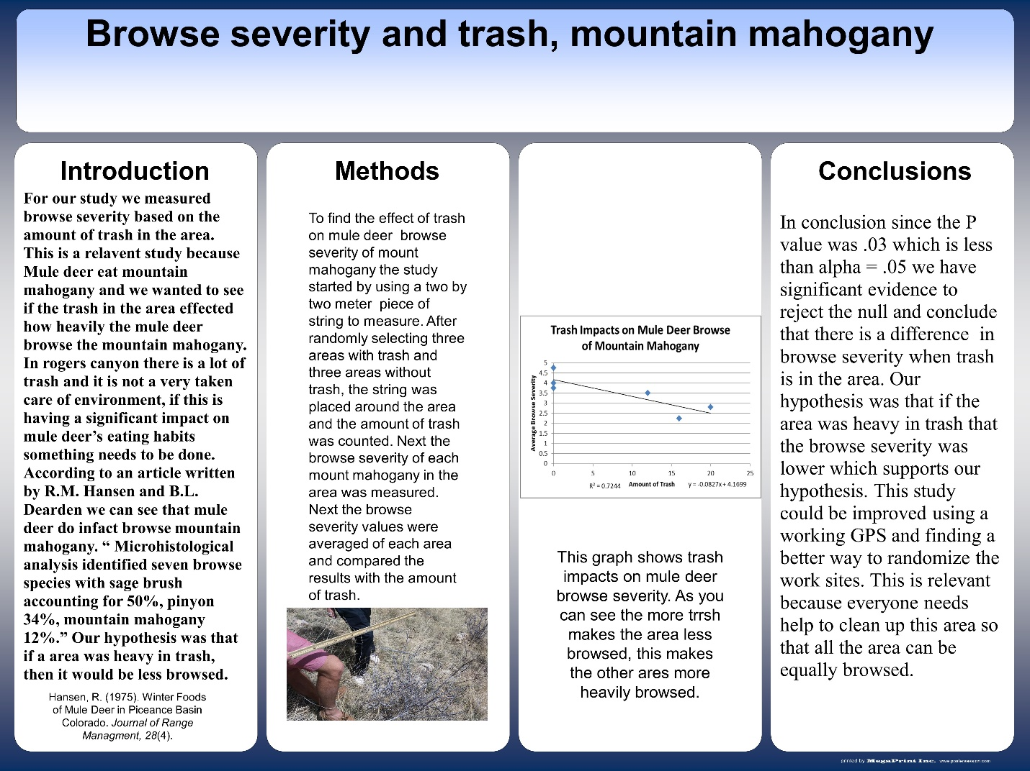
This is an example of a mid-range project. Students do not seem to understand how the research literature informs their study, they seem to have a rudimentary understanding of what the statistics mean, and they do not make a very convincing argument as to what their research results mean.
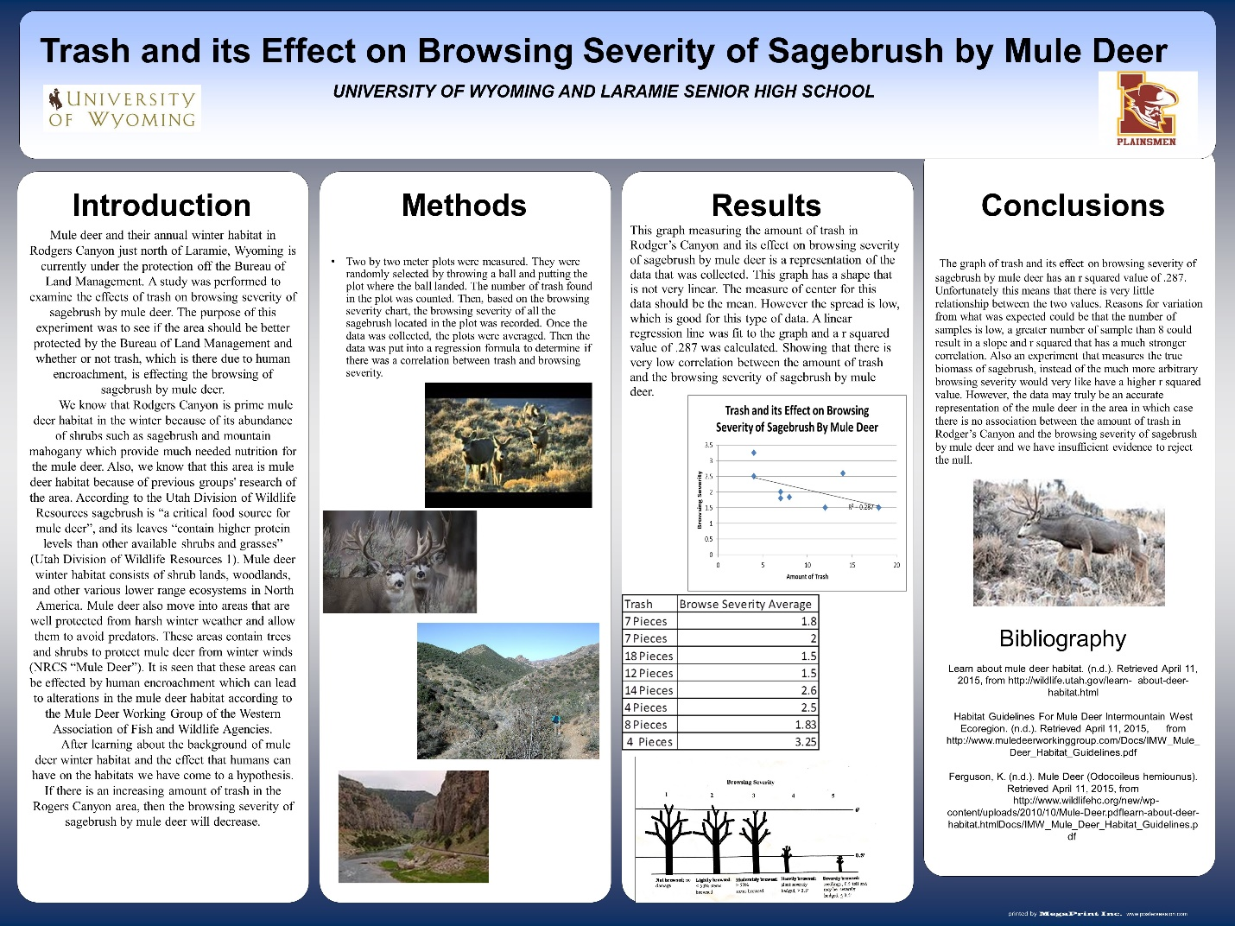
This is an example of one of the higher-end projects. Students seem to have a fairly good understanding of what their study was looking for, how the statistics relate to their research question, and what the results mean.
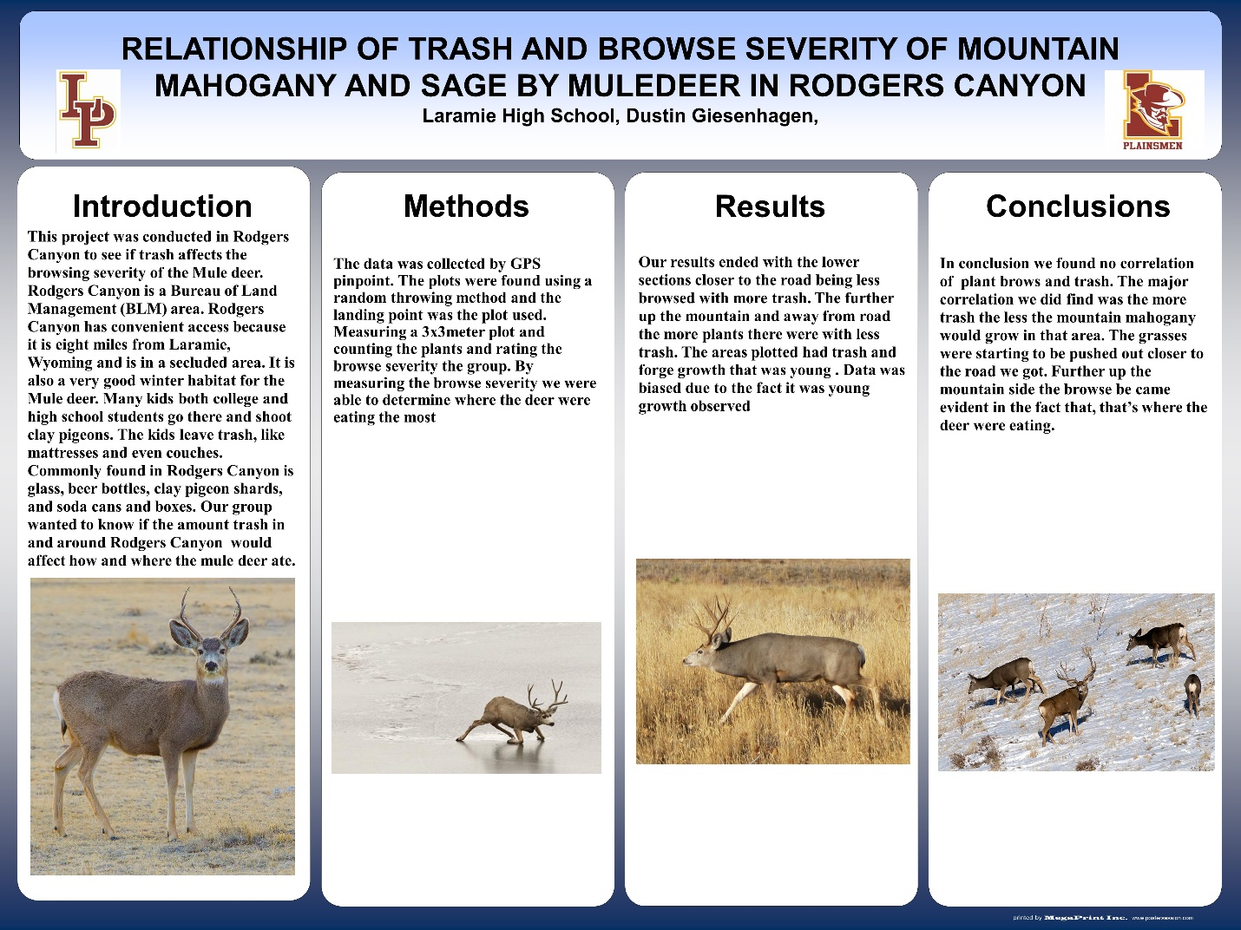
This is an example of a lower end project. Students do not reference any research literature, provide weak descriptions, do not describe any statistical techniques done and their conclusions seem to mostly describe observations rather than collected data.

Successes
Overall this project was very successful, the students seemed to have a good time and get a basic understanding of the concepts as well as the process of field ecology. Dustin, the teacher who led it, expressed that he would definitely do this unit again. He felt that the students got an understanding of doing meaningful field work and the importance for doing good land management. He also felt that students got to see impacts on ecosystems they would not have seen otherwise.
Especially strong in this unit was its organization: first an introduction of the site and some basic field techniques, getting a lecture from a professional in the field, talking about their work, and then going to do it themselves.

Challenges
Interaction with the University
A major goal, if not the main goal, of this project was to connect university research with a high school curriculum. As the project got more and more further along, the connections to the university became less and less. It was hard to connect with university professors as many were busy, especially Matt Kaufmann, of the migration initiative. It was realized fairly late to prioritize connecting with graduate students as they generally seemed to have more time to do outreach like that, and were more interested in doing it. Trying to connect with more researchers at the university should be a priority in the future as this project develops.
Vagueness of research question:
In designing this lesson, it was challenging to develop a research project that the students could design in a short time, with minimal knowledge, that was related to wintering habitat and human impacts, that they could collect all the data in one 60 minute period with enough data points that they could carry out stats on. Since it would be impossible to study the organisms themselves, it was decided to focus on habitat, and especially the food needs with the winter. We still left it very open-ended, but perhaps in the future it would be good to give certain parameters or feed them a list of variables for them to choose from. Discussing this project with more professors might open more ideas as to how this part of the unit could be more robust.
Teaching Statistics:
Statistics were also very challenging to teach as it was probably a bit too lofty to think that introduction stats and several techniques in a 60 minute period could be done. Upon reflection, it was thought that just teaching to regression would be the most useful and that having students pick their two testing variables (two categories of continuous numerical data) would be the best. Regressions are fairly intuitive and would be much simpler to teach to than trying to introduce t-tests, ANOVA, chi-squared, etc.
Weather
This was one thing that many students complained about that not much can be done with. Doing this in early fall or late spring might guarantee better weather
Group Size
Groups ranged in size from 3-6 in the final projects. Keeping them at 3 would make sure all individuals can work together and be able to get things done.
Graduate Student going over research methods
Having a graduate student describe research methods was a part of the field trip day at UW. This was an attempt to connect this unit more with the university, but this can easily be done by the teacher of the unit
Writing
Several students on their post-survey noted that the writing aspect of this unit was challenging. The only writing component was the text that was written on the final posters, as we decided to not include a paper as such a product is not in the scope of Dustin’s class. Perhaps a more rigorous class might consider including a written project, especially if students were exposed to scientific literature. A class period might have to be devoted to teaching students how to write a scientific paper if one is required in the future. Science writing, while maybe tedious, is a large part of science and if framed and taught well would add a lot to this lesson. I was unable to observe the class times when students were doing their write-ups of this lesson, so I do not know if students had trouble writing because too much was expected of them in too little time, or if they did not understand how to write it.
Timing
As with any authentic learning curriculum, timing was a huge limit for this project. We wanted to keep the lesson at 3 weeks, but because of this we had to make several sacrifices to the overall project, one of which, explained next, was the element of service learning/outreach. Students were also very pressed for time to collect their data on a Tuesday and have their final product be ready by that Friday. It might be considered in the future to maybe give students another week or a weekend to work on their final projects.
Service Learning/Outreach
A goal of this lesson, and a way to make it more authentic was to incorporate an element of problem-solving/outreach after the scientific lesson. In this way, the science was informing some kind of community project. This aligns with NGSS Performance Standard HS-LS2-7: Design, evaluate, and refine a solution for reducing the impacts of human activities on the environment and biodiversity. Potential ideas included the class creating a pamphlet to distribute to encourage less destructive use of the area, developing educational materials for local schools, etc. This part of the project ended up being nixed due to the fact that there was no time to do that well. The students’ projects were also not very conducive to informing any such products. Perhaps framing the whole unit as being “there is a problem in Rogers Canyon of how human activity is impacting wildlife. You need to come up with a solution to this, but first you need carry out a scientific study to find out how wildlife are being impacted, in order to come up with a solution.”

Support
According to Dustin, valuable support from the BI on a unit such as this includes:
- Being exposed to sampling methods, such as the allometry of measuring sagebrush biomass
- Having a unit that was simple enough, he could do it mostly on his own
- Supplying good and relevant readings for students
- Creating a guide for students going through the Migration Initiative Atlas
- Providing some kind of professional development

Standards

Next Generation Science Standards
In order to make this a more attractive unit for statewide teachers to pick up, it would be good to show how they align with standards. Next Generation Science Standards Performance Standards that this unit tried to align with include:
- HS-LS2-2 Use mathematical representations to support and revise explanations based on evidence about factors affecting biodiversity and populations in ecosystems of different scales
- HS-LS2-6 Evaluate the claims, evidence, and reasoning that the complex interactions in ecosystems maintain relatively consistent numbers and types of organisms in stable conditions, but changing conditions may result in a new ecosystem
- HS-LS2-7 Design, evaluate, and refine a solution for reducing the impacts of human activities on the environment and biodiversity
This unit ultimately only hit HS-LS2-2 really well. There was an attempt to align with HS-LS2-7 but due to time, this did not happen. There were some elements that applied to HS-LS2-6 tangentially however, this might focus more on climate change and larger-scale disturbances than what was going on at Rogers Canyon.
Disciplinary Core Ideas: The following DCIs would fit well into this lesson:
- LS2-A: Ecosystems have carrying capacities resulting from biotic and abiotic factors. The fundamental tension between resource availability and organism populations affects the abundance of species in any given ecosystem.
- LS2-C: If a biological or physical disturbance to an ecosystem occurs, including one induced by human activity, the ecosystem may return to its more or less original state or become a very different ecosystem, depending on the complex set of interactions within the ecosystem
- LS4-D: Biodiversity is increased by formation of new species and reduced by extinction. Humans depend on biodiversity but also have adverse impacts on it. Sustaining biodiversity is essential to supporting life on Earth
Science and Engineering Practices:
- Asking Questions and Defining Problems: Asking questions and defining problems in 9–12 builds on K–8 experiences and progresses to formulating, refining, and evaluating empirically testable questions and design problems using models and simulations.
- Planning and Carrying out Investigations: Planning and carrying out investigations in 9-12 builds on K-8 experiences and progresses to include investigations that provide evidence for and test conceptual, mathematical, physical, and empirical models.
- Analyzing and Interpreting Data: Analyzing data in 9–12 builds on K–8 experiences and progresses to introducing more detailed statistical analysis, the comparison of data sets for consistency, and the use of models to generate and analyze data
- Using Mathematics and Computational Thinking: Mathematical and computational thinking in 9- 12 builds on K-8 experiences and progresses to using algebraic thinking and analysis, a range of linear and nonlinear functions including trigonometric functions, exponentials and logarithms, and computational tools for statistical analysis to analyze, represent, and model data. Simple computational simulations are created and used based on mathematical models of basic assumptions.
- Constructing Explanations and Designing Solutions: Constructing explanations and designing solutions in 9–12 builds on K–8 experiences and progresses to explanations and designs that are supported by multiple and independent student-generated sources of evidence consistent with scientific ideas, principles, and theories.
- Obtaining, Evaluating and Communitcating Information: Obtaining, evaluating, and communicating information in 9–12 builds on K–8 experiences and progresses to evaluating the validity and reliability of the claims, methods, and designs.
Cross Cutting Concepts:
- Cause and Effect: students understand that empirical evidence is required to differentiate between cause and correlation and to make claims about specific causes and effects. They suggest cause and effect relationships to explain and predict behaviors in complex natural and designed systems. They also propose causal relationships by examining what is known about smaller scale mechanisms within the system. They recognize changes in systems may have various causes that may not have equal effects.
- Systems and Models: students can investigate or analyze a system by defining its boundaries and initial conditions, as well as its inputs and outputs. They can use models (e.g., physical, mathematical, computer models) to simulate the flow of energy, matter, and interactions within and between systems at different scales. They can also use models and simulations to predict the behavior of a system, and recognize that these predictions have limited precision and reliability due to the assumptions and approximations inherent in the models. They can also design systems to do specific tasks.
- Stability and Change: students understand much of science deals with constructing explanations of how things change and how they remain stable. They quantify and model changes in systems over very short or very long periods of time. They see some changes are irreversible, and negative feedback can stabilize a system, while positive feedback can destabilize it. They recognize systems can be designed for greater or lesser stability.

Wyoming State Standards
The following are the Wyoming State Standards that this lesson aligns with. Note that within each standard there are several elements and this lesson only matches with some of those elements.
SC11.1.4: Interdependence of Organisms: Investigate the interrelationships and interdependence of organisms, including the ecosystem concept, energy flow, competition for resources, and human effects on the environment.
SC11.1.5: Matter, Energy, and Organization in Living Systems: Describe the need of living systems for a continuous input of energy to maintain chemical and physical stability. Explain the unidirectional flow of energy and organic matter through a series of trophic levels in living systems. Investigate the distribution and abundance of organisms in ecosystems, which are limited by the availability of matter and energy and the ability of the living system to recycle materials.
SC11.1.6: Behavior and Adaptation: Examine behavior as the sum of responses of an organism to stimuli in its environment, which evolves through adaptation, increasing the potential for species survival. Identify adaptations as characteristics and behaviors of an organism that enhance the chance for survival and reproductive success in a particular environment.
SC11.2.1: Students use research scientific information and present findings through appropriate means.
SC11.2.2: Students use inquiry to conduct scientific investigations.
- Pose problems and identify questions and concepts to design and conduct an investigation.
- Collect, organize, analyze and appropriately represent data.
- Give priority to evidence in drawing conclusions and making connections to scientific concepts.
- Clearly and accurately communicate the result of the investigation.
SC11.2.3: Students clearly and accurately communicate the result of their own work as well as information from other sources.
SC11.3.2: Students examine how scientific information is used to make decisions.
- Interdisciplinary connections of the sciences and connections to other subject areas and career opportunities.
- The role of science in solving personal, local, national, and global problems.
- The origins, limitations, and conservation of natural resources, including Wyoming examples.

Expanding this unit further
This unit was ultimately very place-based focusing on one canyon in the Laramie area. Assuming that most communities have a local piece of land where there is some conflict between human and ungulate use, this unit could be written in a way that a teacher in any city in Wyoming could use. The following is a list of directions this unit could go to expand it to the entire state:
- Robust Data Sets – if it was decided that students really should work with some good data and try to come up with some significant findings, one option would be to go through most of the unit, have students go through the process of hypothesis testing, but then providing them with a dataset of more robust data that has been collected over several years. Some researchers may have some (Jeff Beck, below) they may be willing to contribute. One of the flaws of this unit is that there is not enough time for students to really go out and collect very meaningful data.
- Other technologies that could be incorporated:
- Camera Traps: It was discussed early on that the BI could purchase some wildlife camera traps for teachers to place out on prospective sites. This wouldn’t provide classrooms with a source of quantifiable data, but could provide some insight on the wildlife that uses the research site
- WyoCasts: Graduate Students and/or PIs could do live webcasts of a lecture on research, research techniques, and answering questions for classrooms that are doing this unit. Wyocasts are archived so classrooms that miss them can go back and watch
- Video: the BI could produce short videos with researchers introducing their work, research techniques, statistics and so on that are easily accessible online.
- Professional Development – it is hard to hand a piece of curriculum to a high school teacher and expect them to teach it. If a solid unit curriculum was created, it would be good to have some professional development for educators to work with university researchers and the BI to teach them how to teach this unit including going over research techniques, statistics, current research being done.
- Spreading it out – Perhaps it is too challenging of a project to do within 3 weeks, spreading out the work might make it more manageable for students to complete and get meaning from it.
- More incorporation with actual university research – this unit was tangentially related to university research but it may make it more exciting and/or authentic to have a better connection to a project that is being done. A conversation with Jeff Beck and/or members of the Migration Initiative may help with this.
  - A part of this could be also having strong papers from the university (beyond the Migration Initiative Atlas) for students to read or have access to. A list of 5 sources was created for this unit but never used.

Contacts:
- Dorothy Tuthill – University of Wyoming Biodiverstiy Institute: dtuthill@uwyo.edu
- Amanda Strand: Rangeland Management Specialist of Rogers Canyon: astrand@blm.gov

Summary
This pilot project was overall a success. With a few more tweaks, it will be a great addition for this Laramie High School Ecology course. However, much more work needs to be done in order for this to be able to be distributed statewide. Firstly, it needs to be attractive for biology teachers, this project was developed for an ecology course that is not held to meeting any academic standards. It needs to be written and advertised in a way that teachers will see its worth and will want to use class time to completing it. This means really aligning it with state standards and NGSS. Secondly, it needs to become better connected to the university and research being done there. Perhaps finding one professor or lab that is willing to really work on this would be valuable. Finally, really considering developing a professional development session for distributing this curriculum would probably make teachers much more interested in teaching to this curriculum.
Ungulate and human conflicts are very relevant to all Wyomingites. Developing a high school curriculum that would incorporate this topic with appropriate NGSS, authentic problem-solving, and an experience in the nature of science that could be incorporated throughout the state would be very valuable.

